**Classwork & HW Assignment Sheet for March 12th – 16th**

*This entire packet is due for a 100 point Homework grade on Monday March 19th – no exceptions or late credit given*

* Monday March 12th –Ice Skating Trip – No Class
* Tuesday March 13th – Line Dilations Regents Problems on pages 2-3
* Wednesday March 14th – Transformation Short Answers on pages 4 - 10
* Thursday March 15th –Mock Regents*
* Friday March 16th –Mock Regents*

*\*The mock Regents will be graded on participation (whether you try & show work for EVERY problem) and accuracy (whether you get the problems correct)*

Don’t forget that on Monday March 19th you have the chance to enter the pi day contest by memorizing and reciting the most digits of pi!

If you have any questions – email Ms. Guarnaccia at [guarnacciabeca@gmail.com](mailto:guarnacciabeca@gmail.com) !

***Tuesday March 13th Assignment – Line Dilation Regents Problems***

1 A three-inch line segment is dilated by a scale factor of 6 and centered at its midpoint. What is the length of its image?

|  |  |
| --- | --- |
|  |  |

** 2 Line segment , whose endpoints are  and , is the image of  after a dilation of  centered at the origin. What is the length of ? *Use of graph is optional*

|  |  |
| --- | --- |
|  |  |

3 In the diagram below,  is the image of  after a dilation of scale factor *k* with center *E*.

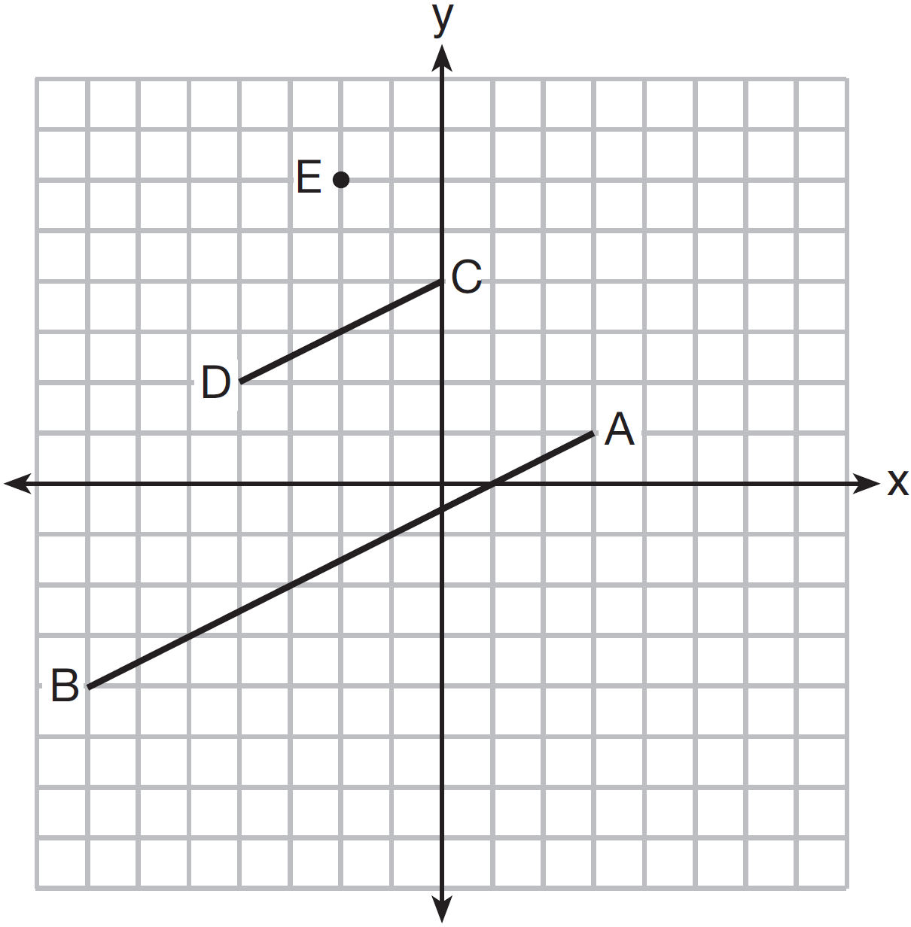

Which ratio is equal to the scale factor *k* of the dilation?

|  |  |
| --- | --- |
| 1) |  |
| 2) |  |
| 3) |  |
| 4) |  |
|  |  |

4 The line  is transformed by a dilation centered at the origin. Which linear equation could be its image?

|  |  |
| --- | --- |
| 1) |  |
| 2) |  |
| 3) |  |
| 4) |  |
|  |  |
|  |  |

5 The equation of line *h* is . Line *m* is the image of line *h* after a dilation of scale factor 4 with respect to the origin. What is the equation of the line *m*?

|  |  |
| --- | --- |
| 1) |  |
| 2) |  |
| 3) |  |
| 4) |  |
|  |  |

6 The line  is dilated by a scale factor of  and centered at the origin. Which equation represents the image of the line after the dilation?

|  |  |
| --- | --- |
| 1) |  |
| 2) |  |
| 3) |  |
| 4) |  |
|  |  |

7 A line that passes through the points whose coordinates are  and  is dilated by a scale factor of 3 and centered at the origin. The image of the line

|  |  |
| --- | --- |
| 1) | is perpendicular to the original line |
| 2) | is parallel to the original line |
| 3) | passes through the origin |
| 4) | is the original line |
|  |  |

8 Line  is mapped onto line *m* by a dilation centered at the origin with a scale factor of 2. The equation of line  is . Determine and state an equation for line *m*.

9* Line  is transformed by a dilation with a scale factor of 2 and centered at . The line's image is

|  |  |
| --- | --- |
| 1) |  |
| 2) |  |
| 3) |  |
| 4) |  |

**\* challenge problem!**

***Wednesday March 14th Assignment – Transformation Regents Short Answers***





What is the image of parallelogram ABCD after the transformation? Write down the coordinates under each transformation and plot and label all three parallelograms on the grid.



1. Triangle *ABC* has the vertices *A*(1,2), *B*(2,5), and *C*(7,4). Find the coordinates of , the image of under the transformation *T*<-2,-7>

Graph and label both triangles. What is the relationship of the lengths of the sides of the two triangles? Justify your answer.

**

1. Quadrilateral *MATH* has the vertices *M*(-2,-1), *A*(1,3), *T*(6,3), and *H*(3,-1). Plot and label the image of quadrilateral *MATH* under the transformation *r*x-axis

State the coordinates of the image. Justify why distances are preserved by the reflection. What type of quadrilateral is *MATH*?

**

4.   
**

**

5. **

**

6. **

**

7.

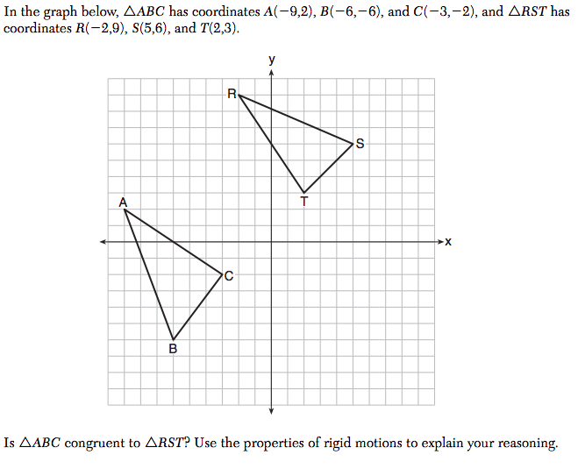

8.

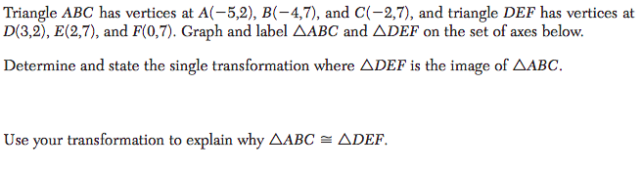

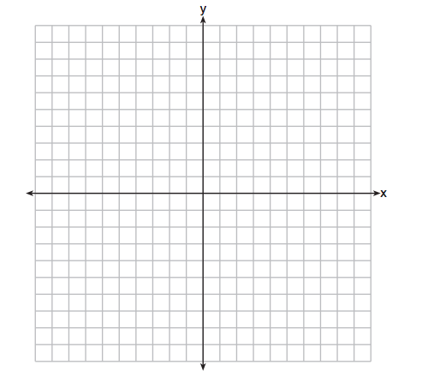

8.   
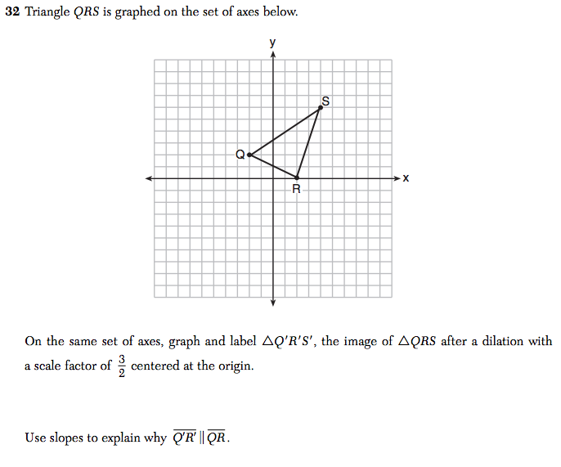

9.

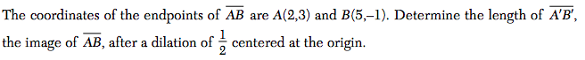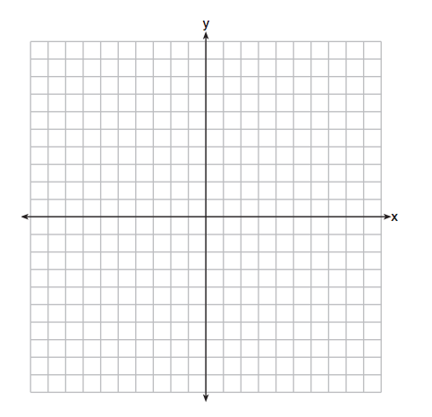

10.  **

**

**11.

**

12.

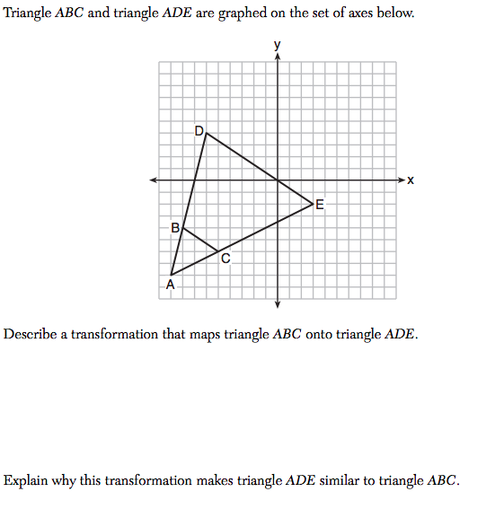



13.

Screen%20Shot%202018-03-07%20at%207.52.48%20PM.png

*Screen%20Shot%202018-03-07%20at%207.53.03%20PM.png*

